Proposal to Install a Southern Railway Semaphore Signal at the Signal Box

Introduction
The disused Billingshurst signal box, which is celebrating its 150th anniversary this year, was commissioned at the museum in 2014. Rather than the box being a static exhibit the emphasis has been on having volunteers demonstrate the process of running trains, which was by passing them along a route from signal box to signal box, and setting signals for the drivers accordingly.
Whilst the commissioning included working equipment for demonstration purposes there are no working signals nor neighbouring signal boxes. However recent improvements have been the addition of a microprocessor to simulate the movement of trains by controlling the lights on the illuminated track circuit diagram and bell code communications with an imaginary signaller in the next signal box along the line.
Together with the operation of the levers in the frame this forms the centre-piece of the signal box.
The signal box levers can all be operated, and frequently are especially by enthusiastic younger visitors, but other than a scale model signal in the box there is nothing to show the results of their efforts.
- Current Situation
There is a redundant signal post in the White Pit area but there is no record of its origin or the date it arrived. The signal box at Amberley was decommissioned in 2014 and from photographs we conclude that it was one of the redundant signals from there. The signal post is fairly unique and dates from the Southern Railway era (1923-1947). The Southern used life-expired running rail as supports in various applications, including signal posts and this is an example. The structure is complete apart from the signal arm, the lamp casing and lamp and mechanical connection.
- Proposal
Install the signal adjacent to the signal box and operating it from one of the signal levers, either mechanically or electrically. The signal is of the old semaphore type with a moving arm, this iconic variety has been in use on the railways in various forms since the 1840s but is now almost completely obsolete and worthy of preservation.
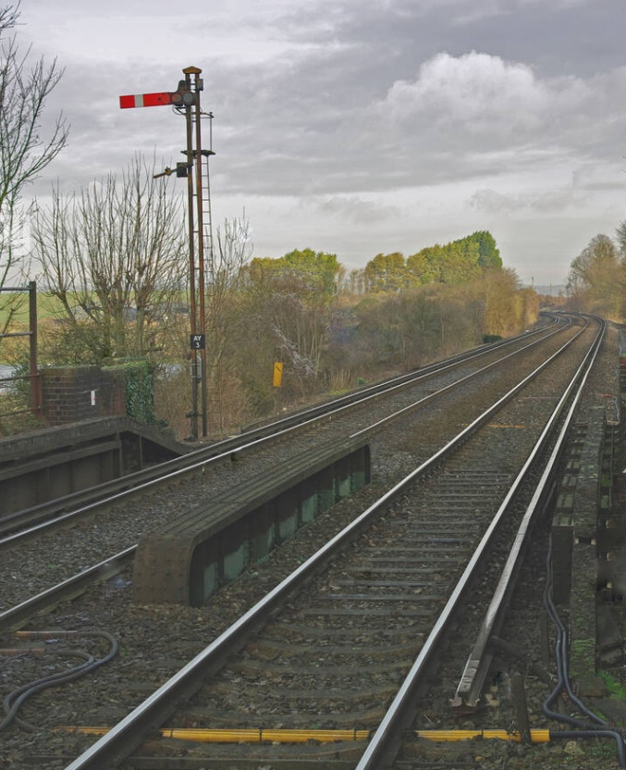
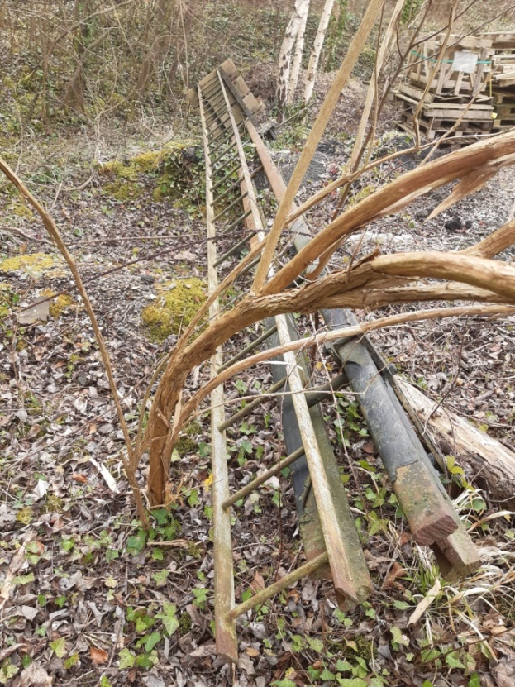
Signal at the white pit area of the museum
Southern Railway semaphore signal at Amberley station

Required Works
The main tasks are as follows:
- Refurbishment of the signal arm, this includes:
Preparation of surfaces and applying coatings
Fitting of any parts that would be difficult once the signal is erected
- Preparation of the signal site:
Excavation, either by hand or using an auger, to a depth of 0.9-1.2m
Formation of a concrete base with a 30Mpa mix
- Moving the signal to site and installing it:
Using a flat bed lorry with a HIAB crane
- Connecting the signal to the signal box:
Either a mechanical link from a signal box lever, or an electrical actuation system

Costs
The refurbishment would be carried out using volunteer labour, although some low cost preparation materials would be required. The signal as delivered is missing the signal arm, a lamp, a counterweight and some minor fittings, although we have already obtained a donated replacement signal arm. Structurally the signal looks sound. More significant would be the cost of the paint eg a 2-pack epoxy (white and black).
Likewise the operating mechanism can be installed with volunteer labour although some low to moderate cost items would be required. A mechanical method (as-per the prototype), only requiring a length of galvanized wire and some small pulleys, would probably be cheaper than an electrical actuator, although would involve more volunteer labour and would require more maintenance activity than an electrical operation.
It should be noted that the cost of installing the signal in a working condition rather than as a static exhibit requires only a relatively small increase in overall cost and is therefore recommended.
Contractors would be required for the following:
Excavation using an auger
Hire of a HIAB lorry with driver/operator

